The Story of boAt: a case of successful start up India

The boAt is an Indian Consumer Electronics Startup, that has revolutionized the way people listen to music. Only within 5 years of its operations, it has become the market leader with a whopping **27.3% market share** in the earwear segment, selling 8,000-10,000 units every day in 2019! How did boAt achieve this? Let’s take a look at the success story of boAt.

We’ll start by looking at the recorded music industry of India, existing competitors, the journey of boAt, its communication strategy, and finally the future.

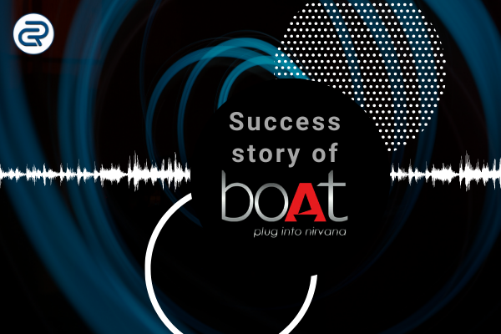

**India’s Music Industry:**

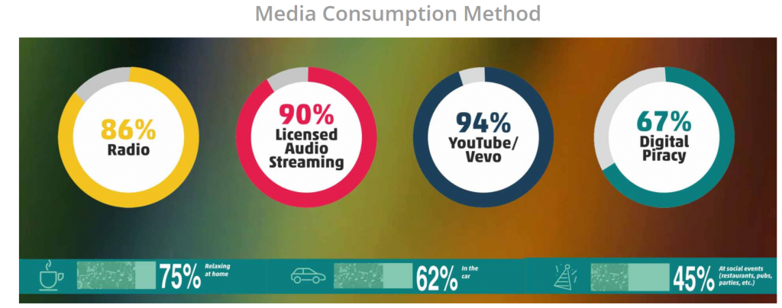

Driven by low data rates and increasing smartphone penetration, the country is witnessing higher traffic towards legitimate sources of music such as OTT platforms, video streaming platforms, etc.

###### **Building a differentiation in a highly competitive market**

To cater to such an extensive and diverse demand, a lot of audio OTT players have started competing in the space. And, to supplement their growth, global companies such as Apple, JBL, Sony, Bose, and Sennheiser have now started offering output devices ranging from wired & wireless earphones and Bluetooth headphones.

But the obvious bummer with these players was the pricing. The prices at which these players were offering their products were way too high vs consumer expectations. We all know India is a price-sensitive market. Secondly, a lot of consumers were accustomed to using bundled headphones that come packaged with the smartphones and hence did not found viable to pay a premium price for just the audio accessories. Third, the pirates and Chinese Products. Street vendors who were selling these counterparts at a much lower price but lacked quality and were not durable. This unfortunately set a perception in the market that paying a premium or “anything extra” for a set of headsets is pointless.

This is where boAt found the opportunity. Before we get into the opportunity itself, let’s understand the Journey of boAt.

###### **The story of boAt**

The two founders **Aman Gupta and Sameer Mehta** started **Imagine Marketing in 2014**, the parent company of boAt, with an initial capital of ₹30 lakh, which they raised from family and friends, this investment helped them leap to their first Product in 2016 — the boAt BassHeads225.

Initially, the founders limited their channels to popular e-commerce platforms like Amazon and Flipkart. But, in May 2018, it caught traction, when **Fireside Ventures** [invested](https://www.livemint.com/Companies/jODewseoAq8ZvbzNyidXAM/Consumer-electrics-startup-boAt-raises-Rs6-crore-from-Fires.html) ₹6 crores and its founder **Kanwaljit Singh** became a key member in the company’s offline strategy. Under his leadership, he opened a few offline stores and in 2019, around 20% of its sales came from these stores.

The insights boAt discovered were simple, yet, powerful ones. During their target consumer (Millennials) research well they found the following insights:

1. This generation in India looked for quality and affordable products. They looked more for a great experience and value for their money invested
2. They wanted the accessories which would go with their lifestyle and are durable
3. They preferred bass-focused music
4. They wanted easy to use products (ex. cables which were easy to untangle)

And hence, they launched a range of products that created a kind of experience that plugged their consumers into Nirvana. Today, their portfolio includes an extensive catalog of headphones, earphones, speakers, travel chargers & premium cables.

Going by the figures, boAt clocked revenue of ₹108 crores in FY2018 from only ₹27 crores in 2017, **a hike of almost 300%.** They have a repeat rate of 30% and are eyeing a revenue of ₹500 crores by 2021. Later, the company went on to add a number of quality products such as earbuds, headphones, smart watches, wireless speakers, etc to its product range. As of December 2020, boAt was already selling 14,000+ products in India every single day. BoAt’s both audio and wearable range offer top-notch quality whilst keeping the price affordable. Established audio electronics brands like JBL had to drop down their prices in order to stay relevant in the target industry.

## boAt Funding

* Kanwaljit Singh of Fireside Ventures invested INR 60 crore in boAt in the year 2018
* Warburg Pincus, a New York-based private equity fund invested $100 million in boAt for a significant minority stake
* The company raised INR 50 crore from Qualcomm Ventures at a valuation of INR 2,200 crore

## boAt Revenue and Marketing Performance

The company struggled in the first two years of its operation (2016-2018), mainly because of the lack of funding. However, once the company raised INR 6 crores from Fireside ventures, there was no looking back. According to filings with the Registrar of Companies, boAt’s FY2018 revenues grew by 4 times to INR 108 crore.

Fast forward FY-2019, boAt became the leading ear wear brand with a 27.3% market share. In FY 2020, the fashionable audio brand generated revenue of INR 500 crore. This was a staggering 108% increase from 239 crore in FY 2019.

When boAt started off, it was just available on popular E-commerce stores like Amazon and Flipkart. However, its products are now available in 5,000+ retail stores. boAt has reportedly served more than 20 million customers so far!

So, what was their strategy to reach this number of audience in such a shorter time?

## boAt Marketing Strategies

The company knows just too well the likes and dislikes of their target audience and the places they visit often- social media, Google, gym, etc. In a nutshell, boAt has targeted the youth of the nation very well as can be seen from the below mentioned marketing strategies:

### 1) Presenting itself as a lifestyle brand

boAt has never portrayed itself as a consumer electronics company. Rather, it has always taken immense pride in presenting itself as a lifestyle accessories brand. Doing so creates an image in the mind of the user that boAt products can be used at all places whether you are sweating in the gym, or commuting in a bus.

This intent of the company was also visible at the Lakme Fashion Week (2009) in Mumbai, where all the models sported only boAt products.

### 2) Digital Marketing

Over the years, the company has spent a lot of money on online marketing, as they have targeted the youth. BoAt has mainly run its campaigns on Google and social networking websites like Facebook and Instagram. Interestingly, all customers of boAt are referred to as ‘boAtheads’. The company has also appointed youth icons such as Kiara Advani to win the trust of the customers.

### 3) Expanding Range of Products

Some companies launch a product, gain success and then fizzle out as they fail to expand their catalo. Expanding your product range over the years is a good marketing strategy in itself and boAt has been exceptional at that. The company first made indestructible apple charging cables and chargers. Tasting success, they did not stop at that introduced ear phones, which was followed by wireless speakers and headphones. With this continuous, well-thought expansion, they were able to capture a large share of the market, owing to which its popularity grew by leaps and bounds.

### 4) The Perfect Targeting

boAt products offer affordability without cutting down on style. This was not a common thing 7 or so years ago, when the market had either premium brands or cheap ones that did not offer an X-factor. The blend of two was rare. BoAt addressed that gap with its products that attracted the youth. The brand ambassadors were also carefully chosen which had a great face value among the millennials, especially from industries such as Bollywood and Sports (Cricket). In terms of quality of the ear wear, the products could be worn without any fear of damaging them even while gymming or performing high-intensity exercise in the outdoors.

###### **5)Communication strategy**

boAt has a community for their audience, all the users of boAt products are called **‘boAtheads’**. Possibly one of the few “Indian” brands to do something on these lines for headsets/earphones. The founders believe in the consumer-first approach, hence they pay attention to what consumers are expressing and then build and modify their products accordingly.

They Sponsored popular youth events like Sunburn, Lakme Fashion week and IPL which striked the right chord of the millennials.

They roped in Brand Ambassadors to whom the audience could relate to, that is, their core target audience. They launched campaigns which further strengthened the brand appeal among the musicophiles. Here are a few of them: Sikhar Dhawan,etc.

## Conclusion

boAt has made a huge name for itself in the last 4 years. It’s reputation and popularity was bolstered after the appearance of one of its co-founders, Aman Gupta, on Shark Tank India season 1. On the marketing, pricing and styling front, the company has left no stone unturned in outsmarting the existing competition. The impact has been such that renowned brands like JBL had to cut down on its prices in order to stay relevant in the industry.

The future of the company looks quite promising, courtesy of a dedicated R&D team, millions in funding and the zeal to stay appealing to the youth. Notably, Aman Gupta’s present net worth is INR 10,500 crore.